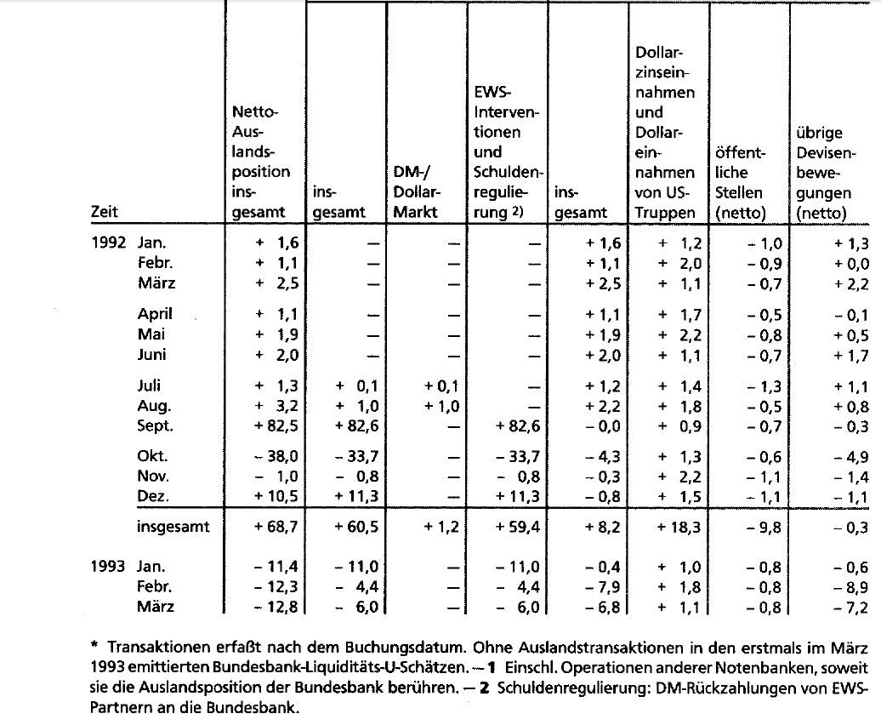

The table on page 47 in the 1992 report (see picture attached) reads “Schuldenregulierung: DM-Rückzahlungen von EWS-Partnern an die Bundesbank.” or roughly “Debt settlements: DM repayments from EMS partners to the Bundesdbank”. So these are not technically speaking interventions but other countries reimbursing the Bundesbank for intervening on their behalf (for previous interventions). It would be interesting to have the detailed breakdown of these numbers and we could then see how much of this was spent on behalf of the UK and other countries. I guess this is probably not shared in the concertation as it is the Bundesbank intervening on behalf of another bank at the limit as the ERM rules require (there is a lot on the Bundesbank threatening to not fulfill its obligations at the margin in the Marsh book).

